Bonus Quiz Chemistry 102
- Do the following
- Create a nucleotide below using the pieces given write the structure at biological pH. The base is cytosine
- Name the nucleotide ___________________________________

- Using any two nucleotides to construct a dinucleotide at biological pH

- How do DNA and RNA differ (give 3 examples)

- What are the three types of RNA and what are their functions?

- What are introns and exons? How does introns influence protein synthesis?

- What is mRNA splicing and when does it occur?

- Give a detailed explanation of translation. Discuss what happens during initiation, elongation, and termination. Be sure to include ALL molecules that play an important role in this process.

- Write the sequence of mRNA that would result from the transcription of the following section of DNA. Write your answer on the blank. Then referring mRNA codons write down the correct amino acid sequence in the polypeptide chain (you can write first 3 letters/abbreviations of amino acids)

DNA strand - TACATAACGGCTATC
mRNA strand -
Amino acid sequence -
- What is a frame shift mutation and explain why a frame shift mutation at the beginning of a gene sequence is more damaging than one at the end of a sequence.

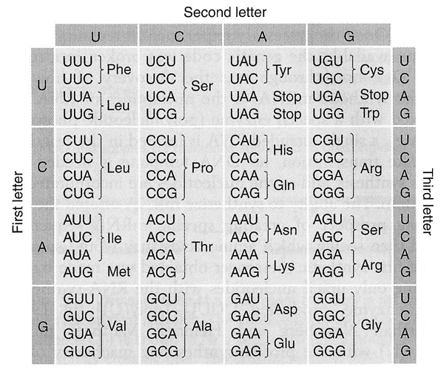

Uracil Adenine Cytosine Guanine thymine

